2.0 PROBLEMS
2.1 Damage of the road surface in the transition zone.
The major issues occurred during construction was the damage of the road surface in the transition zone between the embankment and bridgehead. This caused by a long term process of consolidation settlements. The excessive of embankment settlements with a maximum height of approximate 4.8 meters occurred behind the transition slab, at the contact portion of the embankment structure and the bridgehead. For instance, the lower Silesia. After all of the works involved with the bridge and road construction was completed, the settlements will arise. The size of these settlements will grew to about 5 centimetres and continuously to grow accompanied by the deflection of the road surface. This will significantly be worsening the comfort of driving through the bridge and the distance is approximately 0.5meters from the expansion joint outside the structure. Thus, the cracks in the surface appeared through the perpendicular to its axis.

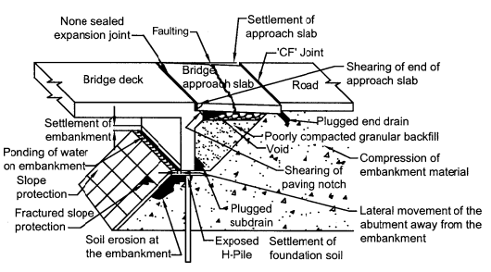
Figure 2.1.1 The possible failure modes at a bridge transition zone

2.2 Inaccurate performance of Subsoil
Moreover, in geotechnical investigation of the subsoil. The subsoil was carried out for the needs of the bridge design, which covered four boreholes up to a depth 12meters for each bridgehead. In figure 2.2.1 the results of soil recognition at the site of the settlements are presented in form of a geotechnical cross section. As it can be seen in the one of the boreholes, a complex of soils was found at a depth from 1.9meters to 5 meters which was interlayered with thin of other soils. The soils are in the form of plastic silts with an organic components content. Thus, in the below the depth of 12 meters there is an accumulation of stiff clay.
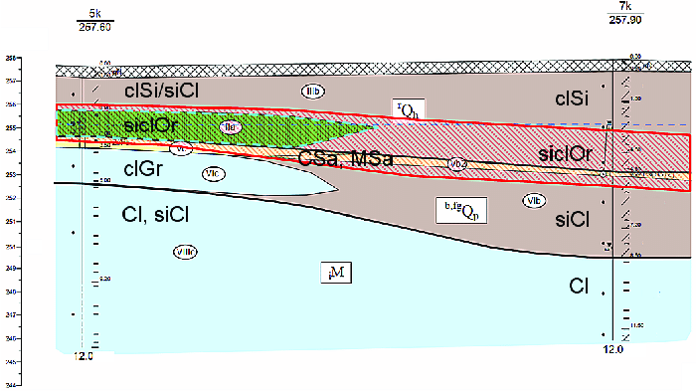
Figure 2.2.1 Geotechnical cross section of 5k to 7k
Organic soils were identified on both sides of the embankment, which were in worse condition plastic to soft plastic. Therefore, the one indicated in the design specification during subsurface research tests were performed to explain the reasons for settlements. The development of low strength soils was also confirmed under the embankment base. There was a variation analysis of the consolidation process was carried out in order to explain the causes for the occurrence of settlements. For the computations, the design documentation's subsoil investigation conditions were determined during the verification tests. Due to the extreme possibility of a drainage effect towards the river has relation to thin interlayers of non-cohesive soils that has found in organic soil layers, several variants of drainage options were explored and with a major impact on the consolidation process over time was considered.
Furthermore, the imprecise belief that the embankment foundation on the layers of load bearing soils will assure excellent load-bearing capacity and road embankment stability. However, in fact all the soil condition is up to the depth of an active zone which must be taken in consideration. In the project specifications, there were no settlement analyses were performed. The likelihood of the excessive and long term settlements will response the organic soil layer package which was not considerate. This is because of the cohesive load bearing soils that occurred the ceiling and the thrill.

